* Connect to Metasploit mysql and create a table in DVWA database.

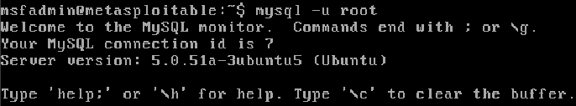

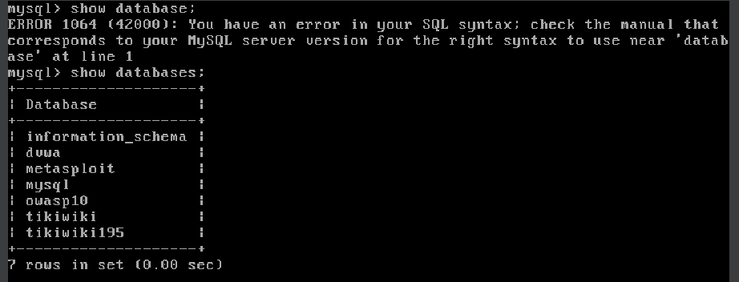

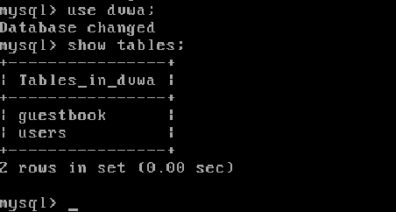

* Use OWASP web server and practice with Command execution, CSRF, File Inclusion and upload attacks types.
* 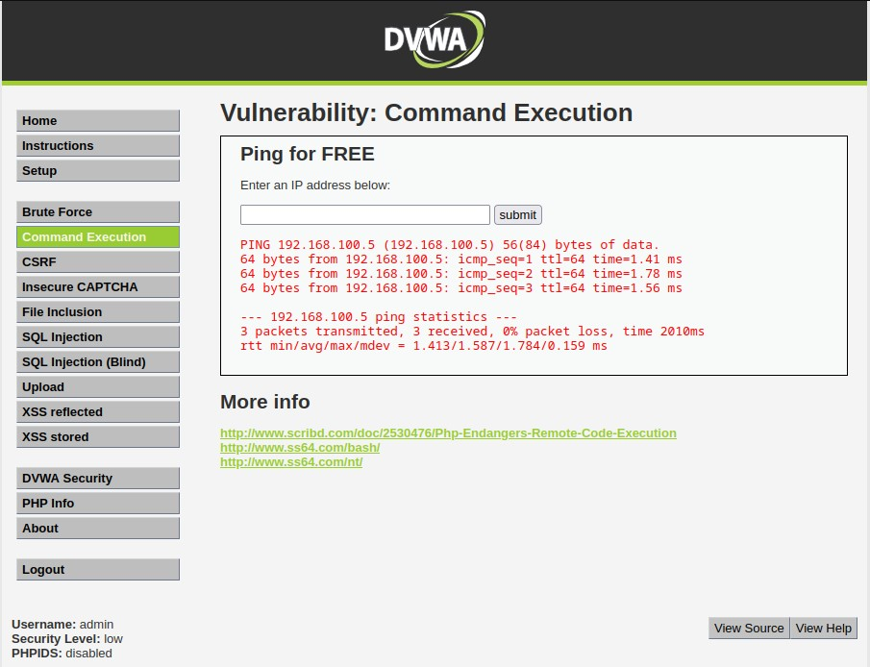Command execution: original IP
* 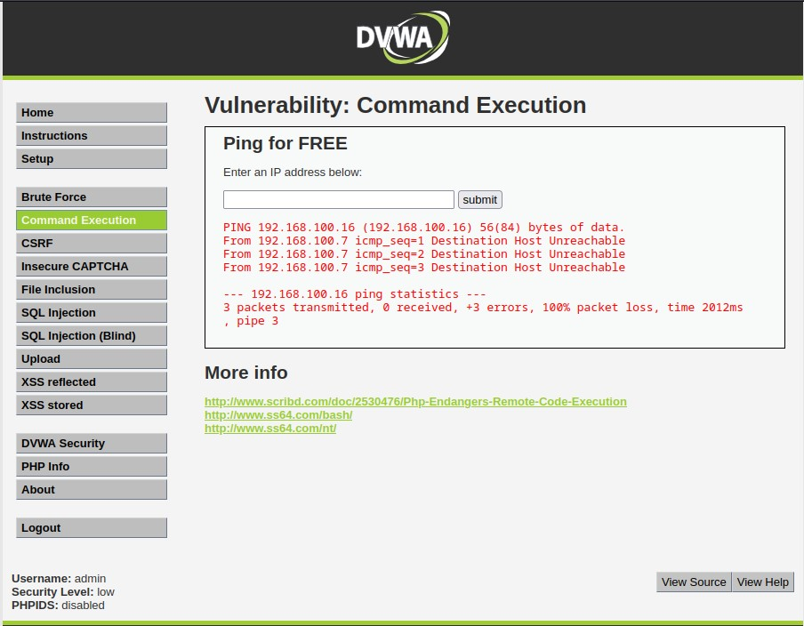Command execution: Fake IP
* 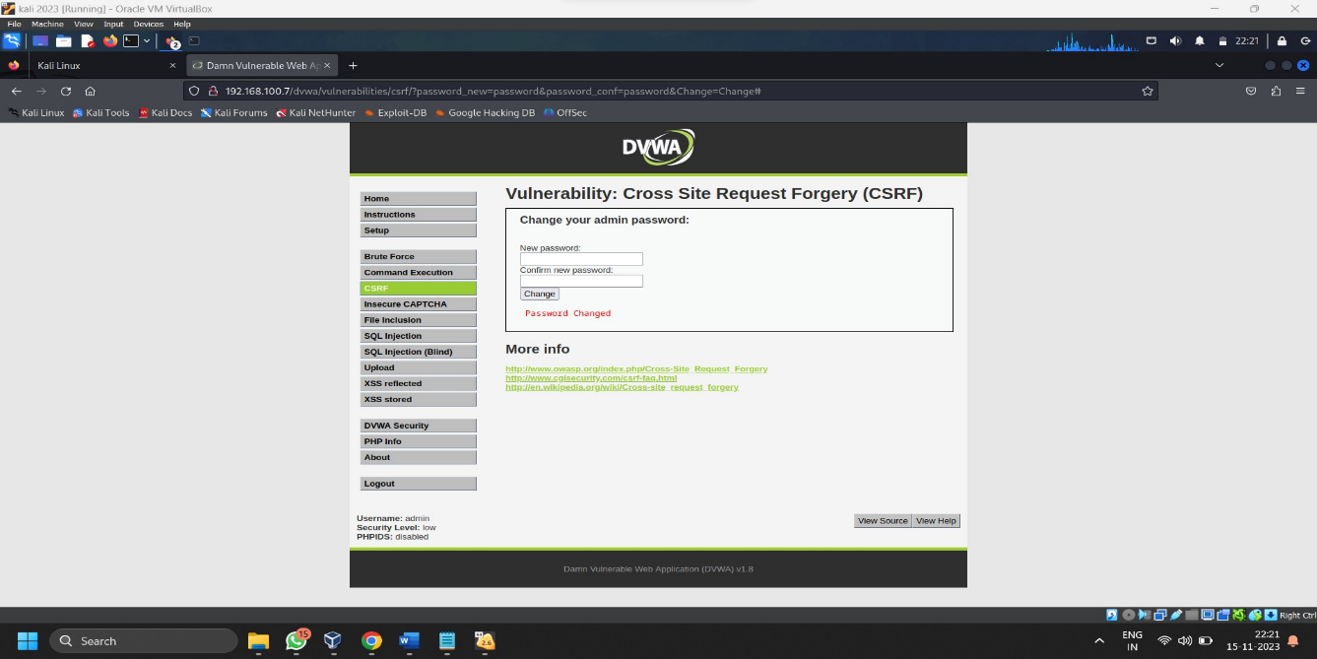CSRF